### **System Architecture Overview**

#### **Introduction**

This document provides an overview of the system architecture for the partner service platform. The system is designed to offer a set of configurable services to a variety of partners. Each partner can access different functionalities, with a tailored configuration of permissions and services. The platform supports multiple user types, each with specific restrictions and capabilities, as detailed below.

#### **Key Components of the System**

1. **Partners**:
   * Partners are external entities that are provided with a set of services by the system.
   * Each partner's services are customizable, and their permissions can be configured independently.
   * Partners are associated with users who access the services based on the partner's configuration.
2. **Users**:
   * Users are categorized into four distinct types: **Guest**, **Basic**, **Company**, and **Advanced**.
   * Each user type has its own set of restrictions based on session time, daily operations, and weekly operations.
   * Users can transition between different statuses as per the business rules.
3. **System Flow**:
   * The system handles user requests through a combination of front-end interfaces, back-end services, and an API layer.
   * The API layer manages the logic for user sessions, including status changes, authorization, and service access.
   * The backend services process the requests, interact with the database, and apply the necessary business rules for user status and operations.

#### **User Types and Statuses**

|  |  |  |  |  |
| --- | --- | --- | --- | --- |
| **User Type** | **Session Time** | **Daily Operations** | **Weekly Operations** | **Possible Transitions** |
| **Guest** | 20 minutes | Max 5 operations per day | Max 20 operations per week | guest → basic → advanced |
| **Basic** | No limit after KYC | Max 20 operations per day | Max 50 operations per week | basic → advanced, advanced → basic, advanced → guest |
| **Company** | No limit | No restrictions | No restrictions | company → advanced, advanced → company |
| **Advanced** | No limit | No restrictions | No restrictions | advanced → basic → guest |

#### 

#### **System Architecture Diagram**

The system architecture involves interactions between users, the front-end, API, backend services, and the database. Users access the services through the front-end, which communicates with the API to request and process data. The backend services handle the core logic and interact with the database to retrieve and update user data.

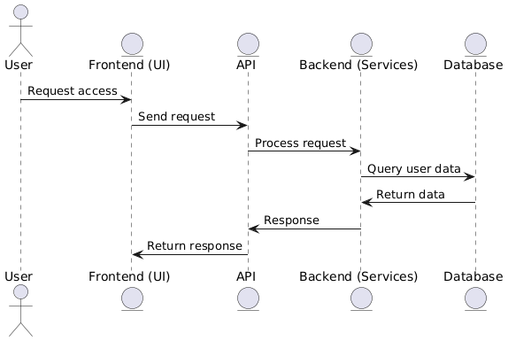

**Figure:** *System Architecture Diagram*